
Champaign Rotary Foundation
“WGRC, Inc.”

Policy Statement #1

Arthur Skelton, Jr. Fellow Program

Purpose: The intent of the Art Skelton Fellow Program is to incentivize Champaign Rotary Club members to contribute to the Champaign Rotary Foundation through recognition of significant donations. Funds contributed will support grant requests that:

- Provide for partnering and matching gift projects that are tangible and self-perpetuating.
- Will be used, primarily, within Champaign County.
- Create partnerships and build good will with other organizations and clubs.
- Increase Rotarians’ participation in projects.
- Provide benefits as broadly to the population as possible.

Process: Champaign Rotary Club Members make contributions specifically to the Champaign Rotary Foundation (Note - Action Auction contributions are not considered Art Skelton Fellow contributions). Art Skelton Fellow recognition is earned for every $1000 contributed by a member. Honorary Art Skelton Fellow recognition will be awarded for non-club members that contribute $1000 or more to the Foundation. Follow-on awards at the $2000 level and above will be recognized as Art Skelton Fellow +1, +2, etc. awards. An Art Skelton Fellow award consists of a certificate documenting this achievement and a commemorative lapel pin for first time awardees.

Responsibilities:

- Foundation President. Oversight of the Art Skelton Fellow program and the planning and execution of recognition events.
- Foundation Secretary. Coordinate with the Foundation Treasurer in maintaining a giving tracker and identifying club members who have reached Art Skelton Fellow designation. The Secretary will also maintain an Art Skelton Fellow recognition banner to be displayed at all normal club meetings and special events.
- Foundation Treasurer. Track and monitor individual club member giving and coordinate with the Foundation Secretary when members achieve Art Skelton Fellow designation. The treasurer will also be responsible for initial coordination of any questions regarding a donor’s intent and whether or not contributions qualify for Art Skelton Fellow recognition.
- Foundation Board Members. Communication about the Art Skelton Fellow program to the club members at large and ensuring that there is broad understanding about the program within the club.

Background:

Art Skelton served as President, District Governor and long time Club Secretary. He was the bedrock upon which today’s club is built. He served as an unofficial advisor to countless club presidents as well as mentor to new members. He was an outstanding Rotarian and served as an excellent example of what Rotary stands for. He worked unceasingly for Rotary and the many projects that Rotary International and Champaign Rotary supported.

The Art Skelton Fellow program was created in 2017 to generate resources for the Art Skelton Fund, which was intended to serve as a giving opportunity for Champaign Rotarians and community leaders focused on fellowship, mutual support, and serving and improving lives in our community. The Art Skelton Fund was envisioned to be a leader in partnering with other agencies as they develop, implement, and sustain significant projects that improve our local community.

The introduction of the Art Skelton Fellow program also coincided with the Champaign Rotary Club’s 100th birthday celebration held on April 1, 2017.

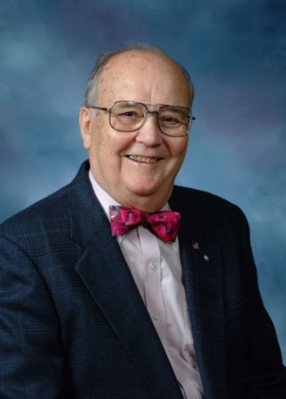
Art Skelton, Jr.

